Department of Geography

College of Science

Swansea University

Singleton Park

Swansea

SA2 8PP

Tel. 01792 602685

[i.c.rutt@swansea.ac.uk](mailto:i.c.rutt@swansea.ac.uk)

20th September 2011

Covering letter re. proposal “Shared frameworks for next-generation ice sheet modelling”

We present for your consideration our proposal for the International Opportunities Fund, second call. It is based on a well-established existing collaboration, but one where the international partners (US) currently have substantial funding which they are devoting to our joint work, whereas the UK side does not. This present proposal aims to leverage maximum benefit for UK climate and cryospheric science from the funding already in place in the US by a carefully thought-out programme of community workshops, infrastructure development and training events. The added-value of this proposal for the UK is substantial.

I wish to explain some aspects of our Project Partner involvement which relate to their institutional processes, but which are not clear from their letters of support:

**CSC, Finland:** The letter of support is signed by Atte Sillanpää, Development Manager at CSC; he is responsible for managing the time of Thomas Zwinger, who is the specialist referred to in the letter. Zwinger is a key developer of the Finite Element code *Elmer*, and a member of the SVALI project (see letter of support from Benn). CSC have not provided an estimate of the monetary value of the time committed to the project; we have estimated this from costings given for an earlier NERC proposal (NE/I02691X/1) where Zwinger’s time was costed in explicitly, and a quote was obtained from CSC.

**Danish Meteorological Institute:** The letter of support is written by Jens Hesselbjerg Christensen, head of the Danish Climate Centre, but in practice our contact is with Dr Gudfinna Aðalgeirsdottir, and it is she we expect to participate actively in the project (see also letter of support from Benn).

Kind regards,

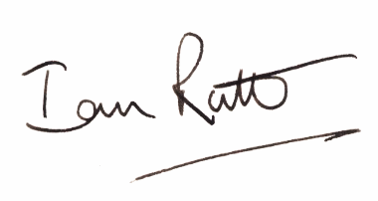

Dr Ian Rutt